Functional Requirements Document (Jupiter Hospital)

Contents

Functional Requirements Document (Jupiter Hospital) 1

**1. Scope** 2

**2. System(s) Impacted** 2

**3. Assumption(s)/Dependencies** 2

**4. As-Is Business Process for User (via activity diagram)** 3

**5. To-Be Business Process for User (via activity diagram)** 5

**6. Requirements** 7

**6.1 Requirements: ‘Doctor Rating’ Module** 7

**6.1.1** **Display ‘Rating’ Dropdown** 7

**6.1.2**  **Display ‘Doctor Summary’ Page** 8

**6.2 Requirements: ‘Appointment Booking’ Page** 9

**6.2.1 ‘Appointment Booking’ page data fields** 9

**6.2.2 ‘Appointment Booking’ page data validations** 10

6.2.2.1 ‘**Appointment Booking**’ page data validation= Pass 11

6.2.2.2 ‘**Appointment Booking**’ page data validation= Fail 11

**6.3 Requirements: ‘Notification and Confirmation’ Message** 12

**6.3.1 ‘Notification & Confirmation’ Message** 12

**6.4 Requirements: ‘Admin/Doctor Dashboard’ Page** 14

**6.4.1 ‘Admin/Doctor Dashboard’ page data fields** 14

**6.5 Requirements: ‘Billing and Offers’ Page** 16

**6.5.1 ‘Billing and Offers’ page data fields** 16

**6.6 Requirements: ‘Ratings & Bill’ Page** 17

**6.6.1‘Ratings & Bill’ page data fields** 17

**7.** Issues/Open Questions 19

**1. Scope**

The scope of this project is to enhance the current Jupiter hospital appointment booking system by adding features and flows to improve scheduling, engagement, and operational visibility. The enhanced system will include:

* ₹100 **refundable appointment deposit** to reduce no-shows
* Slot-based booking with **real-time availability**
* **SMS reminders (2 hours before the appointment time)** + auto-cancellation if the patient doesn’t confirm
* **Admin/Doctor dashboard** showing complete patient details
* **PDF bills** auto-generated post-visit
* **Doctor rating and feedback** collection post-treatment

Incentives: **10% discount** on online payments and **1 free check-up**

These enhancements will improve efficiency, accountability, and patient experience while optimizing doctor scheduling.

**2. System(s) Impacted**

* Enhancement to Jupiter Hospital Mobile Application
* Payment Gateway
* Notification (SMS/Call) System
* Billing Module

**3. Assumption(s)/Dependencies**

* Payment gateway and SMS API are already integrated

**4. As-Is Business Process for User (via activity diagram)**

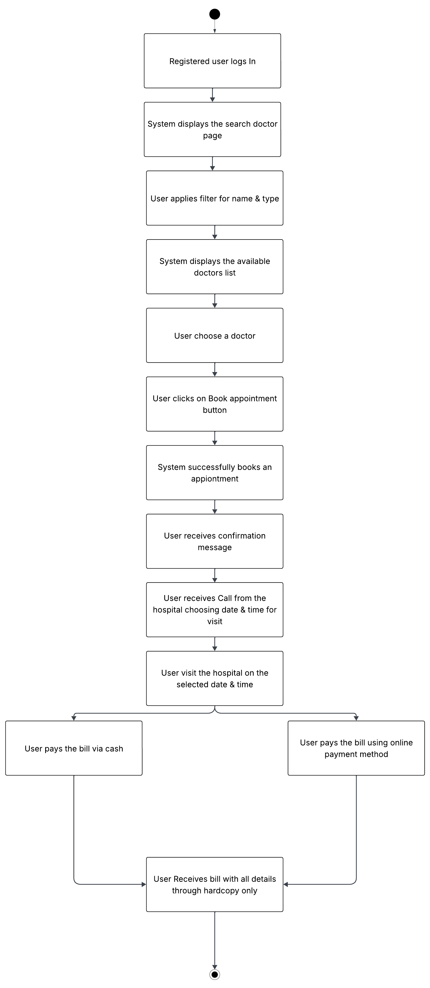

**4.1 As-Is Business Process for Admin (via activity diagram)**

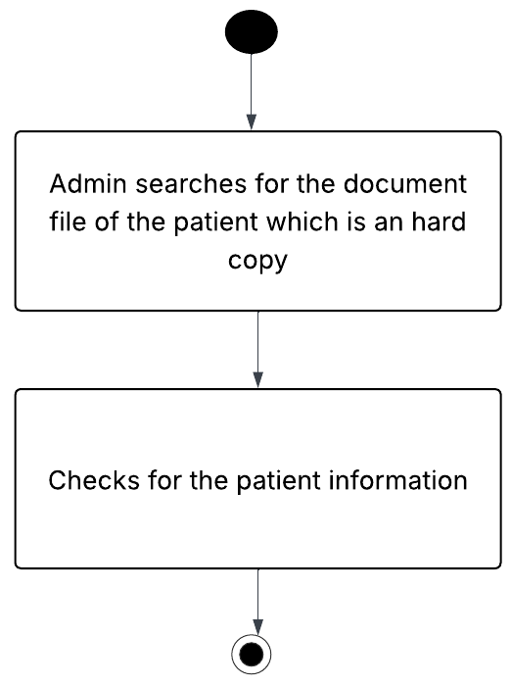

**5. To-Be Business Process for User (via activity diagram)**

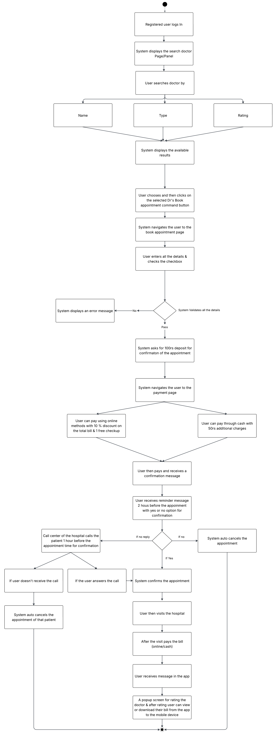

**5.1 To-Be Business Process for Admin (via activity diagram)**

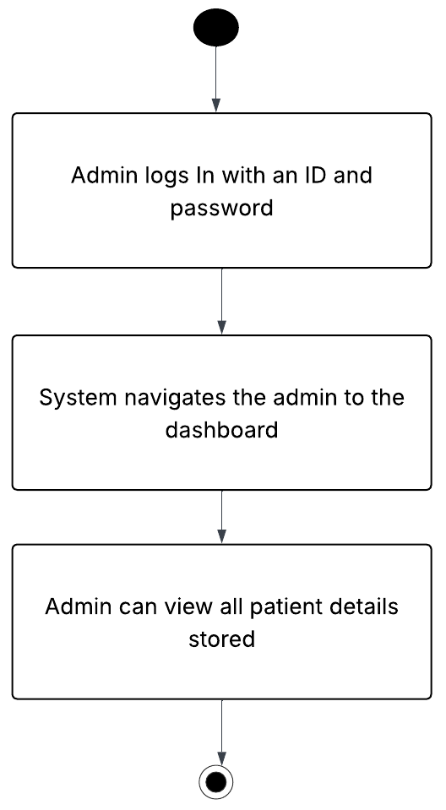

**6. Requirements**

**6.1 Requirements: ‘Doctor Rating’ Module**

### **6.1.1** **Display ‘Rating’ Dropdown**

System shall display ‘Rating’ dropdown, which shall be located to the right of type dropdown, so that users can search doctor by ratings. Also it should display a NEW tag in red so that people can understand it is a new feature add.

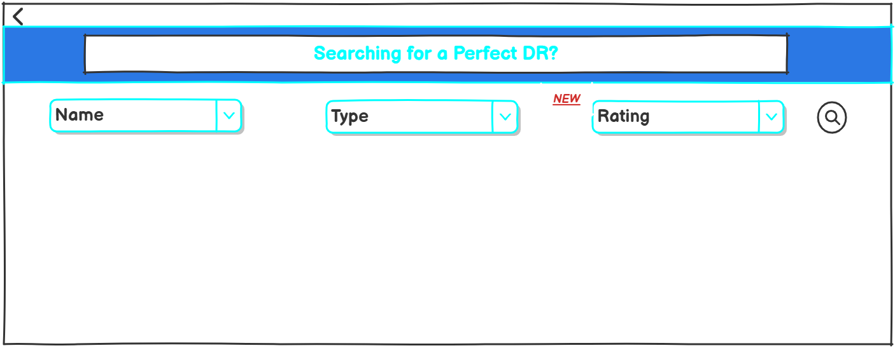

|  |  |  |  |  |  |  |  |
| --- | --- | --- | --- | --- | --- | --- | --- |
| **Sr. No.** | **Field Name** | **Field Type** | **Content** | **Required Field?** | **Min. Char.** | **Max Char.** | **Notes** |
| 1 | Rating | Dropdown | 1,1.5,2,2.5,3,3.5,4,4.5,5 | N/A | N/A | N/A | The dropdown should display different ratings, so that the user can filter and search for a doctor accordingly.  1 → Very Poor  2 → Poor  3 → Average  4 → Good  5 → Excellent |
| 2 | NEW | Label | N/A | N/A | N/A | N/A | The new tag/label describes that it is the new feature added to the application. |

### **6.1.2 Display ‘Doctor Summary’ Page**

### System shall display the doctors available according to the filters applied.

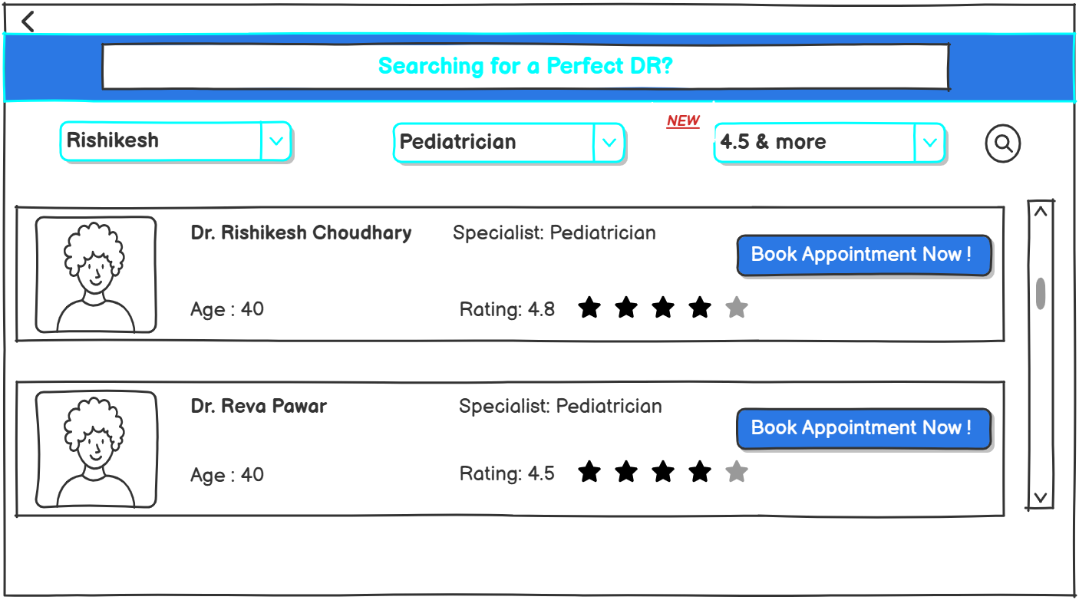

|  |  |  |  |  |  |  |  |
| --- | --- | --- | --- | --- | --- | --- | --- |
| **Sr. No.** | **Field Name** | **Field Type** | **Content** | **Required Field?** | **Min. Char.** | **Max Char.** | **Notes** |
| 1 | Doctor Name | Textbox | Dr. Rishikesh Choudhary  Dr. Reva Pawar | N/A | N/A | N/A | Display full name of the doctor |
| 2 | Doctor Photo | Image | N/A | N/A | N/A | N/A | Image of the doctor  Can be default avatar or uploaded image. |
| 3 | Age | Number | 40,50,60 | N/A | N/A | N/A | Displays the current age of the doctor |
| 4 | Specialist | Textbox | Pediatrician,general,etc | N/A | N/A | N/A | Displays the specialty field of the doctor |
| 5 | Rating | Number | 4, 4.5, 4.9, etc | N/A | N/A | N/A | The rating should include the average of the ratings given by the real patients also with stars for visual appeal. |
| 6 | Book Appointment Now | Command Button | N/A | N/A | N/A | N/A | On click, displays the Appointment booking page. |

**6.2 Requirements: ‘Appointment Booking’ Page**

**6.2.1 ‘Appointment Booking’ page data fields**

System shall display the following data fields on ‘Appointment booking’ page:

- Available Date&Time slots for selected doctor  
 **-** A Basic form to be filled by the patient basic form   
 **-** Including a checkbox for ₹100 refundable deposit during booking an appointment

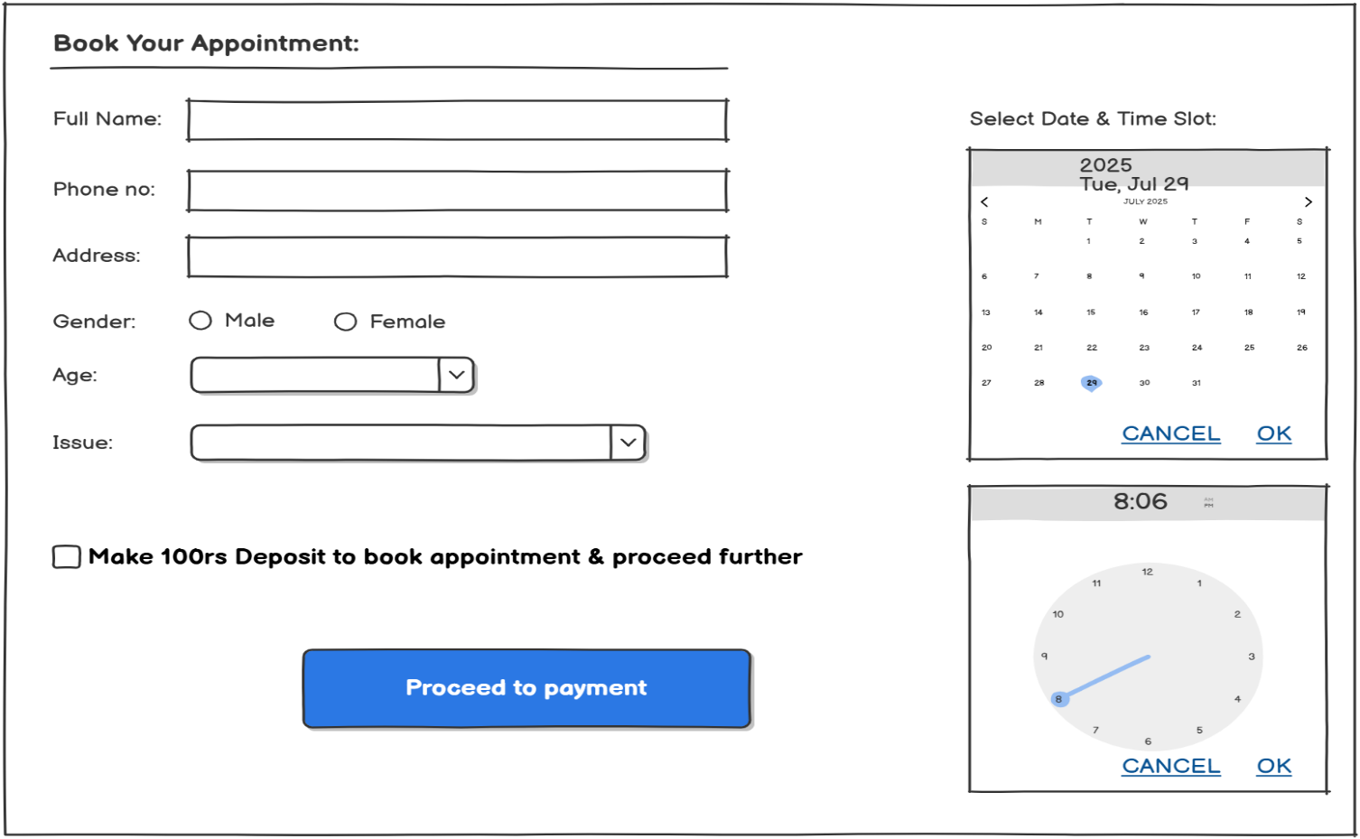

|  |  |  |  |  |  |  |  |
| --- | --- | --- | --- | --- | --- | --- | --- |
| **Sr. No.** | **Field Name** | **Field Type** | **Content** | **Required Field?** | **Min. Char.** | **Max Char.** | **Notes** |
| 1 | Full Name | Textbox | User's full name | Yes | 3 | 50 | Accept only alphabetic characters |
| 2 | Phone Number | Textbox | 10-digit mobile number(numeric) | Yes | 10 | 10 | 10 digit numeric format |
| 3 | Address | Multiline Textbox | Alphanumeric | Yes | 10 | 100 | Can be multiline |
| 4 | Gender | Radio Button | Male, Female | Yes | N/A | N/A | One option must be selected |
| 5 | Age | Dropdown | 1–100 | Yes | 1 | 3 | Only numeric options |
| 6 | Issue | Dropdown | (Fever, Diabetes, Chest Pain, etc.) | Yes | 3 | 50 | Populated from list of common medical issues |
| 7 | Date Picker | Calendar Widget | Select date (e.g., July 29, 2025) | Yes | N/A | N/A | Should not allow past dates  Should strike out the date which are not available for that particular patient |
| 8 | Time Slot | Clock Widget | Select time (e.g., 8:06 AM) | Yes | N/A | N/A | Show only available slots, no double booking |
| 9 | ₹100 Deposit Checkbox | Checkbox | "Make ₹100 deposit..." | Yes | N/A | N/A | Must be checked before enabling "Proceed to Payment" button |
| 10 | Proceed to Payment | Command Button | “Proceed to Payment” | Yes | N/A | N/A | On click, triggers the payment gateway |

**6.2.2 ‘Appointment Booking’ page data validations**

On click of ‘Proceed to payment’ command button, system shall perform following validations:

1. All required data is entered
2. All the entered data is valid
3. Full name should have Min 3 Char and Max 50 Char
4. Only one age is selected
5. Only one gender type is selected
6. Phone number is 10 digit and is active
7. Only single issue is selected
8. Address should have Min 10 Char and Max 100 Char
9. Only one date and time should be selected

### 6.2.2.1 ‘**Appointment Booking**’ page data validation= Pass

In the event of passing of all the validations, the system navigates the user to the already integrated payment page.

### 6.2.2.2 ‘**Appointment Booking**’ page data validation= Fail

In the event of the failure of one or more validations, display the error messages as shown below:

|  |  |
| --- | --- |
| **Failed Validation** | **Error Message Displayed** |
| All required data is entered | <Data Field> is a required field. Please enter a value for <Data Field> |
| All the entered data is valid | Value for <Data Field> is invalid. Please enter a valid value for <Data Field> |
| Full name should have Min 3 Char and Max 50 Char | <Full Name> is invalid. The Min Length is 3 Char and Max is 50 Char . |
| Only one age is selected | Please select an age. |
| Only one gender type is selected | Select a Gender. |
| Phone number is 10 digit and is active | <phone number> is invalid. Enter a 10 Digit Mobile number. |
| Only single issue is selected | <Issue>Please Select an Issue. |
| Address should be Min 10 Char and Max 100 Char | <Address> is invalid. Address should be Min 10 Char and Max 100 Char long. |
| Only one date and time should be selected | <Date> select a Date.  <Time>select a Time |
| "Make ₹100 deposit..." checkbox should be checked | Please confirm your ₹100 deposit to proceed with appointment booking. |

**6.3 Requirements: ‘Notification and Confirmation’ Message**

**6.3.1 ‘Notification & Confirmation’ Message**

System shall display:

SMS with YES/NO confirmation 2 hours before appointment

System shall auto-cancel appointment if call not answered

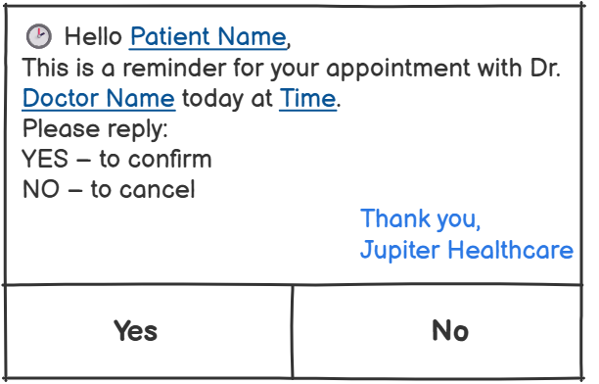

**Note:** This message will be sent 2 hours before the appointment time to the users entered mobile number to get the confirmation from the patient’s side. If not clicked on any of the buttons (yes or No) then the user should get a call from the hospital for the same and if not replied or received the call the system will automatically cancel the appointment booked.

|  |  |  |  |  |  |  |  |
| --- | --- | --- | --- | --- | --- | --- | --- |
| **Sr. No.** | **Field Name** | **Field Type** | **Content** | **Required Field?** | **Min. Char.** | **Max Char.** | **Notes** |
| 1 | Patient Name | Dynamic Text | John Doe | Yes | 1 | 100 | Pulled from patient database based on appointment ID |
| 2 | Doctor Name | Dynamic Text | Dr. Rakesh Mehta | Yes | 1 | 100 | Pulled from doctor database linked to the appointment |
| 3 | Time | Dynamic Text | 10:30 AM | Yes | 5 | 10 | Appointment time to be inserted dynamically linked to the appointment |
| 4 | Reminder Message | Static Text | “This is a reminder…” | Yes | N/A | N/A | Fixed message text |
| 5 | Reply Options | Command Button | YES, NO | Yes | N/A | N/A | Clicking YES or NO sends response to backend |

**6.4 Requirements: ‘Admin/Doctor Dashboard’ Page**

**6.4.1 ‘Admin/Doctor Dashboard’ page data fields**

System shall display the following data fields on ‘**Admin/Doctor Dashboard**’ page:

Display the patient info  
Display payment status (Paid/Not Paid)  
Display patient issues



|  |  |  |  |  |  |  |  |
| --- | --- | --- | --- | --- | --- | --- | --- |
| **Sr. No.** | **Field Name** | **Field Type** | **Content** | **Required Field?** | **Min. Char.** | **Max Char.** | **Notes** |
| 1 | Patient Name | Text | Gaurangi Jamdar | Yes | 1 | 100 | Fetched from patient database |
| 2 | Age | Numeric | 22 | Yes | 1 | 3 | Numeric age of the patient |
| 3 | Gender | Text | Male / Female | Yes | N/A | N/A | Stored as selected value |
| 4 | Address | Text | Andheri East | Yes | 5 | 100 | Patient's entered address |
| 5 | Issue | Text | Stomach Pain | Yes | 3 | 100 | Medical issue selected during booking |
| 6 | Appointment Date & Time | Date & Time | 30/07/2025- 7:30pm | Yes | N/A | N/A | Format: DD/MM/YYYY &HH:MM AM/PM |
| 7 | Payment Status | Label | Done Online / Cash | Yes | N/A | N/A | Indicates payment method also if its paid or not |
| 8 | Payment Icon | Icon Indicator | ✅ / ❗ | Yes | N/A | N/A | Visual representation of status |
| 9 | Search Box | Input Field | Saniya | Optional | N/A | N/A | For filtering/searching patient records by name |

**6.5 Requirements: ‘Billing and Offers’ Page**

**6.5.1 ‘Billing and Offers’ page data fields**

System shall display the following data field on ‘Billing and Offers’ page:

Allows user to apply 10% discount on online payments  
with1 free check-up.

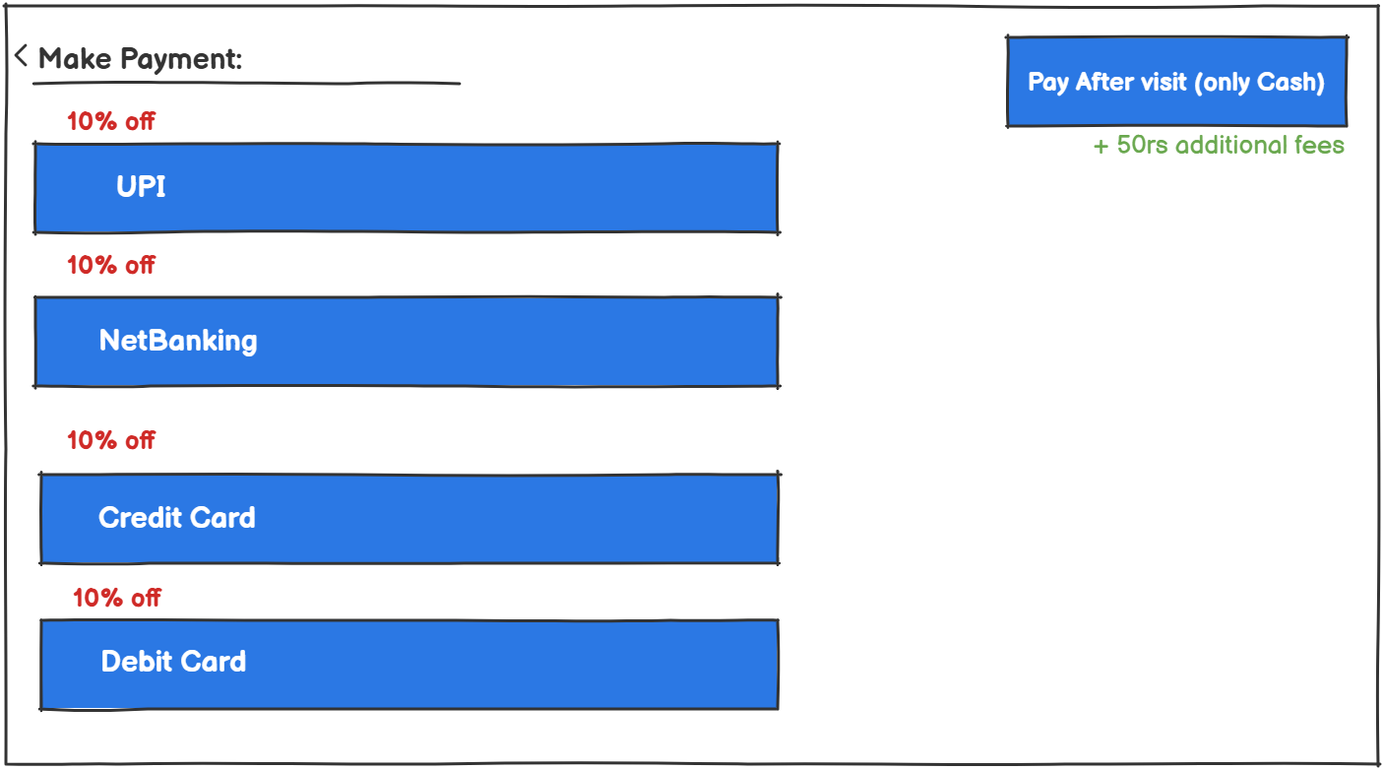

|  |  |  |  |  |  |  |  |
| --- | --- | --- | --- | --- | --- | --- | --- |
| Sr. No. | Field Name | Field Type | Content | Required Field? | Min. Char. | Max Char. | Notes |
| 1 | Discount Message | Label | "10% off" | No | N/A | N/A | Shown for online payment methods only. |
| 2 | Cash Payment Note | Label | "+50rs additional fees" | No | N/A | N/A | Displayed only if "Pay After Visit" (Cash) is selected.  Also on Cash payment charge 50rs extra. |

Note- After the user completes filling all the details on the appointment booking form, system then navigates the user to the payment page where user can pay the 100rs deposit via different online payment methods where they get 10% discount on their bill after the checkup plus a free checkup or by cash which includes 50rs additional fees.

**6.6 Requirements: ‘Ratings & Bill’ Page**

**6.6.1‘Ratings & Bill’ page data fields**

System shall display the following data fields on ‘Ratings & Bill’ page:

After successful payment of the bill after the visit patient should rate the doctor

System auto-generate downloadable bill as PDF

* **This Wireframe is for all the online paid users**

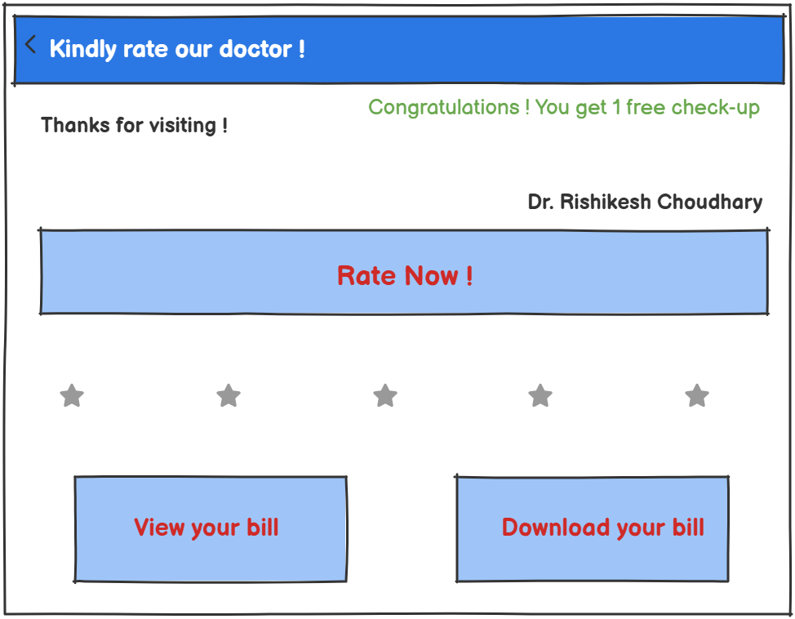

**Note:** User gets this pop up screen after the visit and payment through online methods, also to download or view the bill user should first rate their doctor.

|  |  |  |  |  |  |  |  |
| --- | --- | --- | --- | --- | --- | --- | --- |
| Sr. No. | Field Name | Field Type | Content | Required Field? | Min. Char. | Max Char. | Notes |
| 1 | Doctor Name | Text | Dr. Rishikesh Choudhary | Yes | 3 | 50 | Displayed automatically based on appointment. |
| 2 | Feedback Message | Label | "Thanks for visiting!" | No | 5 | 100 | Can be a dynamic or static message. |
| 3 | Rating Value | Star | 1 to 5 stars | Yes | N/A | N/A | Patient selects from 1–5 stars (mapped as numeric). |
| 4 | Free Check-up | Conditional Text | "You get 1 free check-up!" | No | N/A | N/A | Shown only if patient is eligible (after bill paid online). |
| 5 | Rate Now | Command button | "Rate Now!" | Yes | N/A | N/A | On click, submits the users rating |
| 6 | View Bill Button | Command Button | "View your bill" | Yes | N/A | N/A | Opens bill in-app |
| 7 | Download Bill Button | Command Button | "Download your bill" | Yes | N/A | N/A | Downloads bill as PDF to user’s device. |

* **This Wireframe is for all the offline/cash paid users**

**Note:** User gets this popup screen after the visit and payment through online methods, also to download or view the bill user should first rate their doctor.

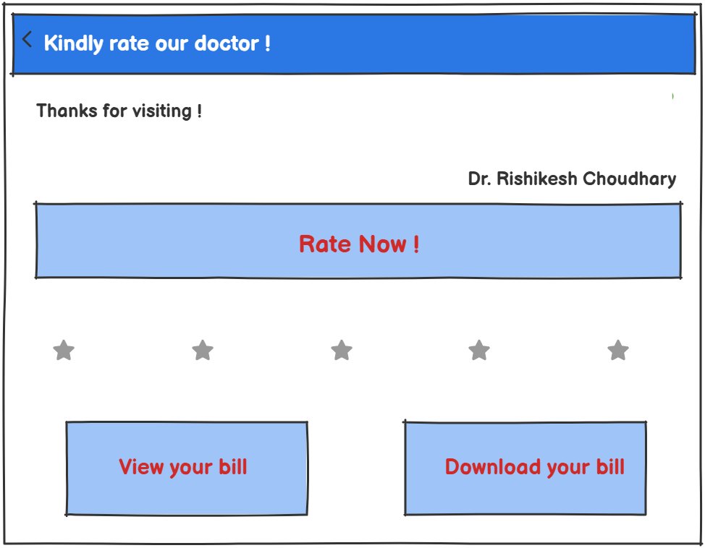

**7.** Issues/Open Questions

* How is the ₹100 deposit refunded after the appointment? Is it automatic or manual?
* Is there a way for doctors to update their available days/hours themselves, or is it controlled by admin?
* What system is used to send SMS reminders? Is it integrated via an API or done manually?
* Can patients give feedback multiple times, or is it restricted to once per visit?
* Are the 10% discounts for online payments applied automatically? How are they tracked in billing?